Random Forest Regression in Python
Every decision tree has high variance, but when we combine all of them together in parallel then the resultant variance is low as each decision tree gets perfectly trained on that particular sample data, and hence the output doesn’t depend on one decision tree but on multiple decision trees. In the case of a classification problem, the final output is taken by using the majority voting classifier. In the case of a regression problem, the final output is the mean of all the outputs. This part is called Aggregation.

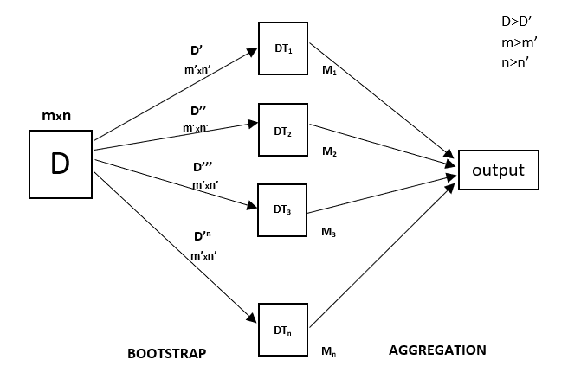
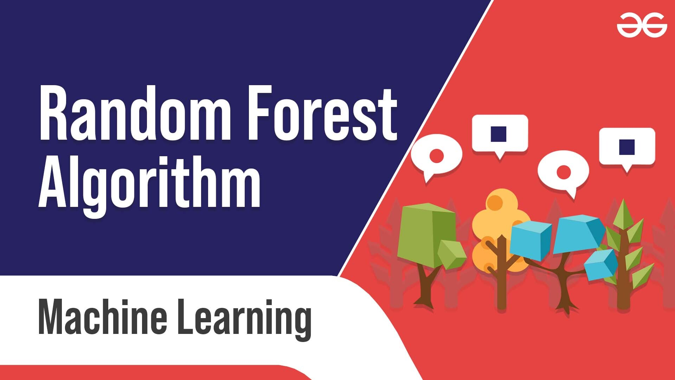
Random Forest is an ensemble technique capable of performing both regression and classification tasks with the use of multiple decision trees and a technique called Bootstrap and Aggregation, commonly known as bagging. The basic idea behind this is to combine multiple decision trees in determining the final output rather than relying on individual decision trees.
Random Forest has multiple decision trees as base learning models. We randomly perform row sampling and feature sampling from the dataset forming sample datasets for every model. This part is called Bootstrap.
We need to approach the Random Forest regression technique like any other machine learning technique
- Design a specific question or data and get the source to determine the required data.
- Make sure the data is in an accessible format else convert it to the required format.
- Specify all noticeable anomalies and missing data points that may be required to achieve the required data.
- Create a machine learning model
- Set the baseline model that you want to achieve
- Train the data machine learning model.
- Provide an insight into the model with test data
- Now compare the performance metrics of both the test data and the predicted data from the model.
- If it doesn’t satisfy your expectations, you can try improving your model accordingly or dating your data, or using another data modeling technique.
- At this stage, you interpret the data you have gained and report accordingly.
You will be using a similar sample technique in the below example.
Below is a step-by-step sample implementation of Random Forest Regression.
Implementation:
Step 1: Import the required libraries.

# Importing the libraries
import numpy as np
import matplotlib.pyplot as plt
import pandas as pd

Step 2: Import and print the dataset

data = pd.read_csv('Salaries.csv')
print(data)

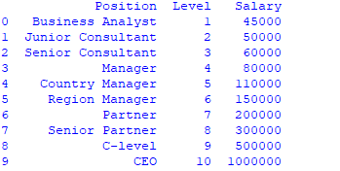
Step 3: Select all rows and column 1 from dataset to x and all rows and column 2 as y
# the coding was not shown which is like that
x= df.iloc [:, : -1] # ” : ” means it will select all rows, “: -1 ” means that it will ignore last column
y= df.iloc [:, -1 :] # ” : ” means it will select all rows, “-1 : ” means that it will ignore all columns except the last one
# the “iloc()” function enables us to select a particular cell of the dataset, that is, it helps us select a value that belongs to a particular row or column from a set of values of a data frame or dataset.
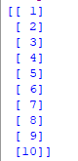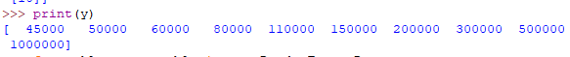
Step 4: Fit Random forest regressor to the dataset

# Fitting Random Forest Regression to the dataset
# import the regressor
from sklearn.ensemble import RandomForestRegressor

# create regressor object
regressor = RandomForestRegressor(n_estimators = 100, random_state = 0)

# fit the regressor with x and y data
regressor.fit(x, y)

Output:
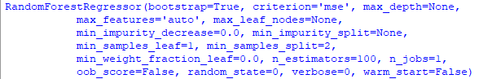
Step 5: Predicting a new result

Y_pred = regressor.predict(np.array([6.5]).reshape(1, 1)) # test the output by changing values

Step 6: Visualising the result

# Visualising the Random Forest Regression results

# arrange for creating a range of values
# from min value of x to max
# value of x with a difference of 0.01
# between two consecutive values
X_grid = np.arrange(min(x), max(x), 0.01)

# reshape for reshaping the data into a len(X_grid)*1 array,
# i.e. to make a column out of the X_grid value
X_grid = X_grid.reshape((len(X_grid), 1))

# Scatter plot for original data
plt.scatter(x, y, color = 'blue')

# plot predicted data
plt.plot(X_grid, regressor.predict(X_grid),
color = 'green')
plt.title('Random Forest Regression')
plt.xlabel('Position level')
plt.ylabel('Salary')
plt.show()

Output:
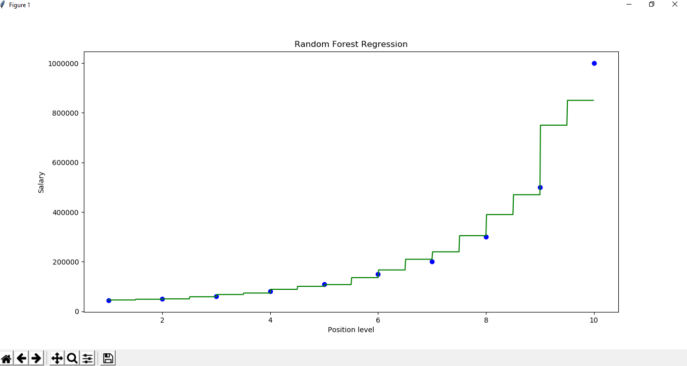

Ensemble Classifier | Data Mining
Ensemble learning helps improve machine learning results by combining several models. This approach allows the production of better predictive performance compared to a single model. Basic idea is to learn a set of classifiers (experts) and to allow them to vote.

Advantage : Improvement in predictive accuracy.
Disadvantage : It is difficult to understand an ensemble of classifiers.
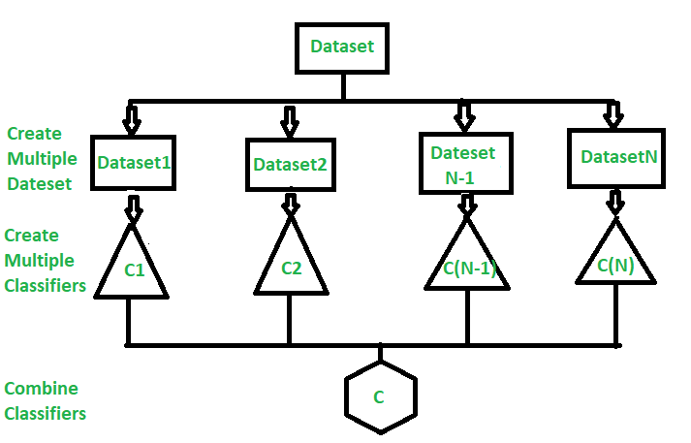
Why do ensembles work?
Dietterich(2002) showed that ensembles overcome three problems –
- Statistical Problem –
The Statistical Problem arises when the hypothesis space is too large for the amount of available data. Hence, there are many hypotheses with the same accuracy on the data and the learning algorithm chooses only one of them! There is a risk that the accuracy of the chosen hypothesis is low on unseen data!
- Computational Problem –
The Computational Problem arises when the learning algorithm cannot guarantees finding the best hypothesis.
- Representational Problem –
The Representational Problem arises when the hypothesis space does not contain any good approximation of the target class(es).
Main Challenge for Developing Ensemble Models?
The main challenge is not to obtain highly accurate base models, but rather to obtain base models which make different kinds of errors. For example, if ensembles are used for classification, high accuracies can be accomplished if different base models misclassify different training examples, even if the base classifier accuracy is low.
Methods for Independently Constructing Ensembles –
- Majority Vote
- Bagging and Random Forest
- Randomness Injection
- Feature-Selection Ensembles
- Error-Correcting Output Coding
Methods for Coordinated Construction of Ensembles –
- Boosting
- Stacking
Reliable Classification: Meta-Classifier Approach
Co-Training and Self-Training
Types of Ensemble Classifier –
Bagging:
Bagging (Bootstrap Aggregation) is used to reduce the variance of a decision tree. Suppose a set D of d tuples, at each iteration i, a training set Di of d tuples is sampled with replacement from D (i.e., bootstrap). Then a classifier model Mi is learned for each training set D < i. Each classifier Mi returns its class prediction. The bagged classifier M* counts the votes and assigns the class with the most votes to X (unknown sample).
Implementation steps of Bagging –
- Multiple subsets are created from the original data set with equal tuples, selecting observations with replacement.
- A base model is created on each of these subsets.
- Each model is learned in parallel from each training set and independent of each other.
- The final predictions are determined by combining the predictions from all the models.
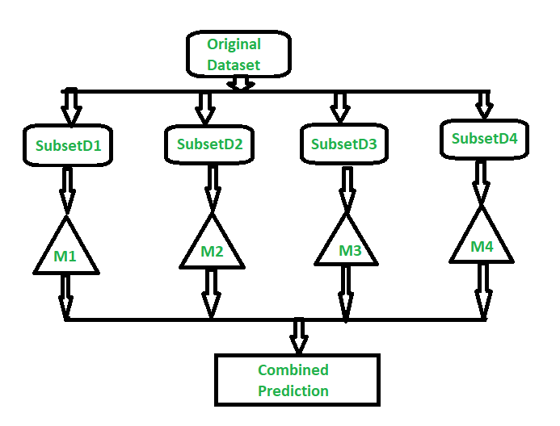
Random Forest:
Random Forest is an extension over bagging. Each classifier in the ensemble is a decision tree classifier and is generated using a random selection of attributes at each node to determine the split. During classification, each tree votes and the most popular class is returned.
Implementation steps of Random Forest –
  - Multiple subsets are created from the original data set, selecting observations with replacement.
  - A subset of features is selected randomly and whichever feature gives the best split is used to split the node iteratively.
  - The tree is grown to the largest.
  - Repeat the above steps and prediction is given based on the aggregation of predictions from n number of trees.
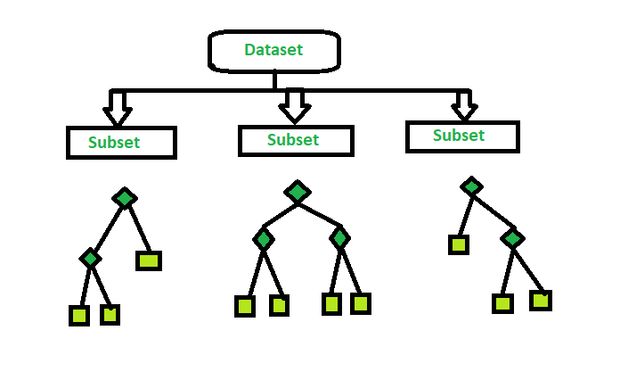
You can learn read more about in the sklearn documentation.

ML | Voting Classifier using Sklearn
A Voting Classifier is a machine learning model that trains on an ensemble of numerous models and predicts an output (class) based on their highest probability of chosen class as the output.
It simply aggregates the findings of each classifier passed into Voting Classifier and predicts the output class based on the highest majority of voting. The idea is instead of creating separate dedicated models and finding the accuracy for each them, we create a single model which trains by these models and predicts output based on their combined majority of voting for each output class.

Voting Classifier supports two types of votings.
- Hard Voting: In hard voting, the predicted output class is a class with the highest majority of votes i.e the class which had the highest probability of being predicted by each of the classifiers. Suppose three classifiers predicted the output class(A, A, B), so here the majority predicted A as output. Hence A will be the final prediction.
- Soft Voting: In soft voting, the output class is the prediction based on the average of probability given to that class. Suppose given some input to three models, the prediction probability for class A = (0.30, 0.47, 0.53) and B = (0.20, 0.32, 0.40). So the average for class A is 0.4333 and B is 0.3067, the winner is clearly class A because it had the highest probability averaged by each classifier.
Note: Make sure to include a variety of models to feed a Voting Classifier to be sure that the error made by one might be resolved by the other.
Code : Python code to implement Voting Classifier
# importing libraries
from sklearn.ensemble import VotingClassifier
from sklearn.linear_model import LogisticRegression
from sklearn.svm import SVC
from sklearn.tree import DecisionTreeClassifier
from sklearn.datasets import load_iris
from sklearn.metrics import accuracy_score
from sklearn.model_selection import train_test_split

# loading iris dataset
iris = load_iris()
X = iris.data[:, :4]
Y = iris.target

# train_test_split
X_train, X_test, y_train, y_test = train_test_split(X,
Y,
test_size = 0.20,
random_state = 42)

# group / ensemble of models
estimator = []
estimator.append(('LR',
LogisticRegression(solver ='lbfgs',
multi_class ='multinomial',
max_iter = 200)))
estimator.append(('SVC', SVC(gamma ='auto', probability = True)))
estimator.append(('DTC', DecisionTreeClassifier()))

# Voting Classifier with hard voting
vot_hard = VotingClassifier(estimators = estimator, voting ='hard')
vot_hard.fit(X_train, y_train)
y_pred = vot_hard.predict(X_test)

# using accuracy_score metric to predict accuracy
score = accuracy_score(y_test, y_pred)
print("Hard Voting Score % d" % score)

# Voting Classifier with soft voting
vot_soft = VotingClassifier(estimators = estimator, voting ='soft')
vot_soft.fit(X_train, y_train)
y_pred = vot_soft.predict(X_test)

# using accuracy_score
score = accuracy_score(y_test, y_pred)
print("Soft Voting Score % d" % score)

Output :
Hard Voting Score 1
Soft Voting Score 1
Examples:
Input :4.7, 3.2, 1.3, 0.2
Output :Iris Setosa
In practical the output accuracy will be more for soft voting as it is the average probability of the all estimators combined, as for our basic iris dataset we are already overfitting, so there won’t be much difference in output.

ML | Bagging classifier
A Bagging classifier is an ensemble meta-estimator that fits base classifiers each on random subsets of the original dataset and then aggregate their individual predictions (either by voting or by averaging) to form a final prediction. Such a meta-estimator can typically be used as a way to reduce the variance of a black-box estimator (e.g., a decision tree), by introducing randomization into its construction procedure and then making an ensemble out of it.
Each base classifier is trained in parallel with a training set which is generated by randomly drawing, with replacement, N examples(or data) from the original training dataset – where N is the size of the original training set. Training set for each of the base classifiers is independent of each other. Many of the original data may be repeated in the resulting training set while others may be left out.

Bagging reduces overfitting (variance) by averaging or voting, however, this leads to an increase in bias, which is compensated by the reduction in variance though.
How Bagging works on training dataset ?
How bagging works on an imaginary training dataset is shown below. Since Bagging resamples the original training dataset with replacement, some instance(or data) may be present multiple times while others are left out.
Original training dataset: 1, 2, 3, 4, 5, 6, 7, 8, 9, 10
Resampled training set 1: 2, 3, 3, 5, 6, 1, 8, 10, 9, 1
Resampled training set 2: 1, 1, 5, 6, 3, 8, 9, 10, 2, 7
Resampled training set 3: 1, 5, 8, 9, 2, 10, 9, 7, 5, 4
Algorithm for the Bagging classifier:
Classifier generation:

Let N be the size of the training set.
for each of t iterations:
sample N instances with replacement from the original training set.
apply the learning algorithm to the sample.
store the resulting classifier.

Classification:
for each of the t classifiers:
predict class of instance using classifier.
return class that was predicted most often.
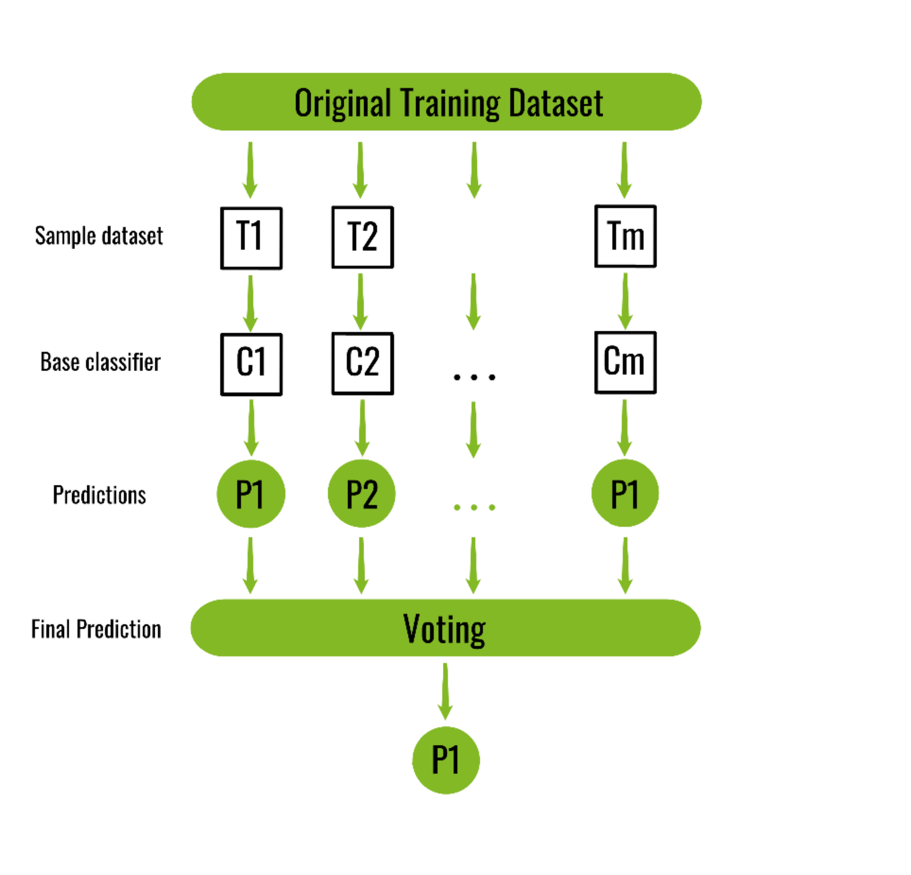
Below is the Python implementation of the above algorithm:
from sklearn import model_selection
from sklearn.ensemble import BaggingClassifier
from sklearn.tree import DecisionTreeClassifier
import pandas as pd

# load the data
url = "/home/debomit/Downloads/wine_data.xlsx"
dataframe = pd.read_excel(url)
arr = dataframe.values
X = arr[:, 1:14]
Y = arr[:, 0]

seed = 8
kfold = model_selection.KFold(n_splits = 3,
random_state = seed)

# initialize the base classifier
base_cls = DecisionTreeClassifier()

# no. of base classifier
num_trees = 500

# bagging classifier
model = BaggingClassifier(base_estimator = base_cls,
n_estimators = num_trees,
random_state = seed)

results = model_selection.cross_val_score(model, X, Y, cv = kfold)
print("accuracy :")
print(results.mean())

Output:
accuracy :
0.8372093023255814

